WEEK 3 DELIVERABLE (TEAM 9)

TRAINED MODELS AND PREDICTION REPORT
RIT Opportunity-Wise Student Participation & Engagement Analysis
Task distribution. The team distributed the Week 3 work into five roles: Role 1 (Data Preparation and Features), Role 2 (Model Building and Evaluation), Role 3 (Predictions and Forecasting), Role 4 (Visualisation) and Role 5 (Report Compilation and Quality Review).
The contributors below are listed with the role number they worked under.

Project Metadata | Details
Deliverable Title | Trained Models And Prediction Report
Dataset | Week 2 Cleaned Dataset, Sheet “Week2 Cleaned Data”: 8,558 Application Records × 36 Columns, 22 Opportunities (23 IDs), 5 Categories
Modelling Population | 8,344 Resolved Records (4,072 Participated; 4,272 Not Participated). 214 Unresolved Records (Applied Or Waitlisted) Are Scored, Not Used For Training Or Evaluation
Target | Participated = Started, Team Allocated Or Rewards Award; Not Participated = Rejected, Dropped Out Or Withdraw
Models Compared | Logistic Regression, Random Forest, Gradient Boosting
Validation | 5-Fold StratifiedGroupKFold Grouped By Opportunity ID (Every Fold Is Tested On Unseen Opportunities)
Selected Model | Random Forest (F1 0.830, ROC-AUC 0.897, Accuracy 85.1%)
Unit Of Analysis | Application Records, Not Unique Learners (The Dataset Has No Learner ID)
Week 2 Data (Model Input) | Week 2 cleaned dataset (Google Sheets)
Week 3 Prediction Tables | Week 3 prediction tables (Google Sheets)
Week 3 Analysis Code | Week 3 analysis script (Google Drive)
Data Dictionary | Data Dictionary (Google Sheets)

Contributors
Team member (email) | Contribution to the Week 3 deliverables
Khadija Kamal <khadijakamal6002@gmail.com> | Role 2, Model Building And Evaluation: Three Models, Grouped Cross-Validation, Model Selection, Saved Model Handoff
Kamoru Olayemi Raji <Kamo4nice@gmail.com> | Initial Chronological-Split Modelling (Colab), Model-Workflow Infographic, SQL And Cohort Consolidation
Barira Khan <khanbarira47@gmail.com> | Role 3, Probability Scores, Opportunity Ranking, Category Performance, Quarterly Analysis And Volume Scenarios
Oladosu Rophiat <olasubomi166@gmail.com> | Role 3, Probability Workbook, Feature Importance, Confusion-Matrix And Heatmap Analysis, Quarterly Forecast
Nour Ahmed <nourahmet77777@gmail.com> | Role 4, Model-Diagnostic Charts And Calibration Analysis (R Scripts)
Ghufran Khan <iamghufrankhan1@gmail.com> | Cleaned Dataset And Derived Features Used As The Modelling Input
Victor Thompson <victor.thompsonva97@gmail.com> | Cleaned Dataset And Derived Features Used As The Modelling Input
This report compiles the individual submissions into one document. Where submissions disagreed, the figures were recalculated from the data and the verified result is reported (Appendix A).

1. Executive Summary
This report presents the Week 3 models and predictions for the RIT opportunity dataset: trained models and their evaluation, predicted participation probabilities for each opportunity, and a quarterly view of demand with a forecast.
- Models. Three models were trained on 8,344 resolved records. Validation held out whole opportunities in each of five folds, so every score describes opportunities the model had not seen. Random Forest was selected: F1 0.830, accuracy 85.1%, precision 0.935, recall 0.746, ROC-AUC 0.897 (0.5 means guessing, 1.0 means perfect ranking).
- Category drives the prediction. Shuffling Opportunity Category lowers ROC-AUC by 0.344; no other input lowers it by more than 0.014. A rule that labels every non-internship as “participates” scores the same F1 (0.829). The model adds value in ranking and probabilities: ROC-AUC 0.897 against 0.853 for the category-only rule.
- Ranking. Probabilities for resolved records come from a model that never saw their opportunity. Thirteen opportunities (courses, events, competitions, engagement) are rated High (82% to 96%); all nine internships are Low (16% to 29%). Differences inside a tier are small and do not form a meaningful order.
- Internships. Within internships the model has little skill (ROC-AUC 0.65, recall 11%). Health Care Management is the largest miss: predicted 18%, observed 55%. Learner-level fields do not explain differences between internships.
- Peak quarter. 2024 Q1 is the peak: 4,785 applications (55.9% of all records) and about 1,861 expected participants (1,649 recorded among resolved records). The base-case forecast repeats the peak in the first quarter after the data ends (2025 Q1 in the forecast labelling): about 4,785 applications and 1,861 expected participants (planning band 3,589 to 5,981 applications).
- Why participation falls. Observed participation drops from 96% (2023 Q2) to 36% (2024 Q1) because internships grow from 5% to 73% of applications, not because learners disengage.
- Reliability. One annual cycle of history exists, and simple volume forecasts in Week 2 missed by about 50% on average in backtests. The forecast is a set of planning scenarios, not a validated prediction.

In plain terms
What we predicted: whether an application ends in participation (started, allocated or rewarded).
How well: about 85% of applications are classified correctly, but almost all of this comes from knowing the type of opportunity. Courses, events, competitions and engagement activities lead to participation about 99% of the time; internships about 22%.
What we cannot yet do: tell one internship from another using learner details alone. The model has little skill inside internships.
How to use the forecast: as a planning range. The busiest quarter is the first quarter of the year, and internships decide how many applicants end up participating.

2. Dataset, Target and Scope
The input is the Week 2 cleaned dataset (8,558 application records, 36 columns), covering apply dates from 5 October 2022 to 10 April 2024. Each row is one application. There are 22 opportunity names (23 IDs, because Jump Start: Developing your Emotional Intelligence has two IDs) in five categories: Internship (5,421 records), Course (2,037), Event (545), Competition (425) and Engagement (130). The workbook can be opened here: Week 2 cleaned dataset (Google Sheets).
The target is the dataset-defined Participated label from Week 2. It groups statuses and is not a verified measure of completion: for example, Team Allocated counts as Participated.
Table 1: Target definition and record counts
Group | Statuses included | Records | Use in this report
Participated (1) | Started 767; Team Allocated 3,276; Rewards Award 29 | 4,072 | Training and evaluation
Not Participated (0) | Rejected 3,569; Dropped Out 617; Withdraw 86 | 4,272 | Training and evaluation
Unresolved | Applied 105; Waitlisted 109 | 214 | Scored only (no final outcome)
Total |  | 8,558

3. Methodology

3.1 Prediction point and variables selected
The model predicts at the point of learner signup, using eleven fields that are known before any outcome. Opportunity Name was deliberately left out, so the model must learn from the opportunity’s category and the learner profile. This allows it to be tested on opportunities it has never seen.
Table 2: Model input variables and preparation
Variable | Type | Preparation
Opportunity Category | Categorical | Most-frequent imputation; one-hot encoding (categories seen fewer than 10 times are grouped)
Gender, Country, Institution Name, Current/Intended Major | Categorical | Same as above; rare institutions, countries and majors fall into the grouped level
Signup_Month, Signup_Quarter, Signup_Weekday, Signup_Weekend | Categorical (calendar) | Same as above; month and weekend are treated as categories, not as linear numbers
Age_at_Signup, Signup_Year | Numeric | Median imputation; standardisation

Variables excluded to prevent leakage or memorisation:
- Status Description, Status Code and Participated: they are the outcome itself.
- Opportunity Start Date and the four columns derived from it (Application_Lead_Time_Days, Already_Started, Signup_To_Opportunity_Start_Days, Opportunity_Duration_Days). The start date is filled for all 4,072 Participated records but blank for 3,580 of the 4,272 Not Participated records, so whether it is filled reveals the result.
- Apply Date and other application-derived fields: not known at signup.
- Names, dates of birth, Opportunity Name and Opportunity Id. Opportunity Id is used only to group the validation folds.

3.2 Preprocessing and validation
Preprocessing is fitted inside each training fold, so no information passes from validation records to training. Validation uses five-fold StratifiedGroupKFold (random_state = 42) grouped by Opportunity Id. No opportunity appears in both the training and validation parts of a fold, which tests how the model performs on unseen opportunities and is stricter than a random row split. All 8,344 resolved records receive one out-of-fold prediction. The 214 unresolved records are scored by the final model fitted on all resolved records.
The validation was re-run for this report. The confusion matrices of all three models match the Role 2 submission exactly (Section 4.2).
The models were run on the Week 2 sheet as submitted. Among its resolved records it still contains 13 test accounts and 101 records whose apply date is before the signup date. Re-running the validation without the test accounts gives F1 0.831 and ROC-AUC 0.897; without both groups, F1 0.829 and ROC-AUC 0.892 (as submitted: 0.830 and 0.897). No measure moves by more than 0.006, so the conclusions do not depend on these rows.

3.3 Algorithms and settings
Table 3: Algorithm settings (baseline configurations; no exhaustive tuning)
Model | Settings
Logistic Regression | C = 1.0; max_iter = 2000; solver = lbfgs; random_state = 42
Random Forest | n_estimators = 100; max_features = sqrt; min_samples_leaf = 2; random_state = 42
Gradient Boosting | n_estimators = 150; learning_rate = 0.05; max_depth = 2; min_samples_leaf = 10; random_state = 42

3.4 Model selection rule
F1-score for the Participated class is the primary criterion. Models within 0.005 F1 of the best are treated as practically tied, and ROC-AUC decides between them. The rule was fixed before the models were compared.

4. Trained Models and Evaluation

4.1 Model performance comparison
How to read the measures. Accuracy is the share of all predictions that are correct. Precision is the share of predicted participants who really participated. Recall is the share of real participants the model found. F1 balances precision and recall. ROC-AUC measures how well the model ranks participants above non-participants (0.5 is guessing, 1.0 is perfect). The Brier score is the average squared error of the probabilities (lower is better).
Table 4: Pooled out-of-fold performance (positive class = Participated)
Model | Accuracy | Precision | Recall | F1-score | ROC-AUC | Brier score
Logistic Regression | 0.8494 | 0.9551 | 0.7254 | 0.8246 | 0.8696 | 0.1180
Random Forest (selected) | 0.8506 | 0.9350 | 0.7456 | 0.8296 | 0.8971 | 0.1121
Gradient Boosting | 0.8587 | 0.9798 | 0.7254 | 0.8336 | 0.8641 | 0.1156
Benchmark: category-only rule | 0.8567 | 0.9894 | 0.7139 | 0.8294 | 0.8533 | 0.1132
Benchmark: majority class | 0.4880 | 0.4880 | 1.0000 | 0.6559 | 0.5000 | –
The category-only rule predicts Participated for every non-internship record and Not Participated for every internship. Its Brier score uses each category’s observed participation rate as the probability. Lower Brier is better.
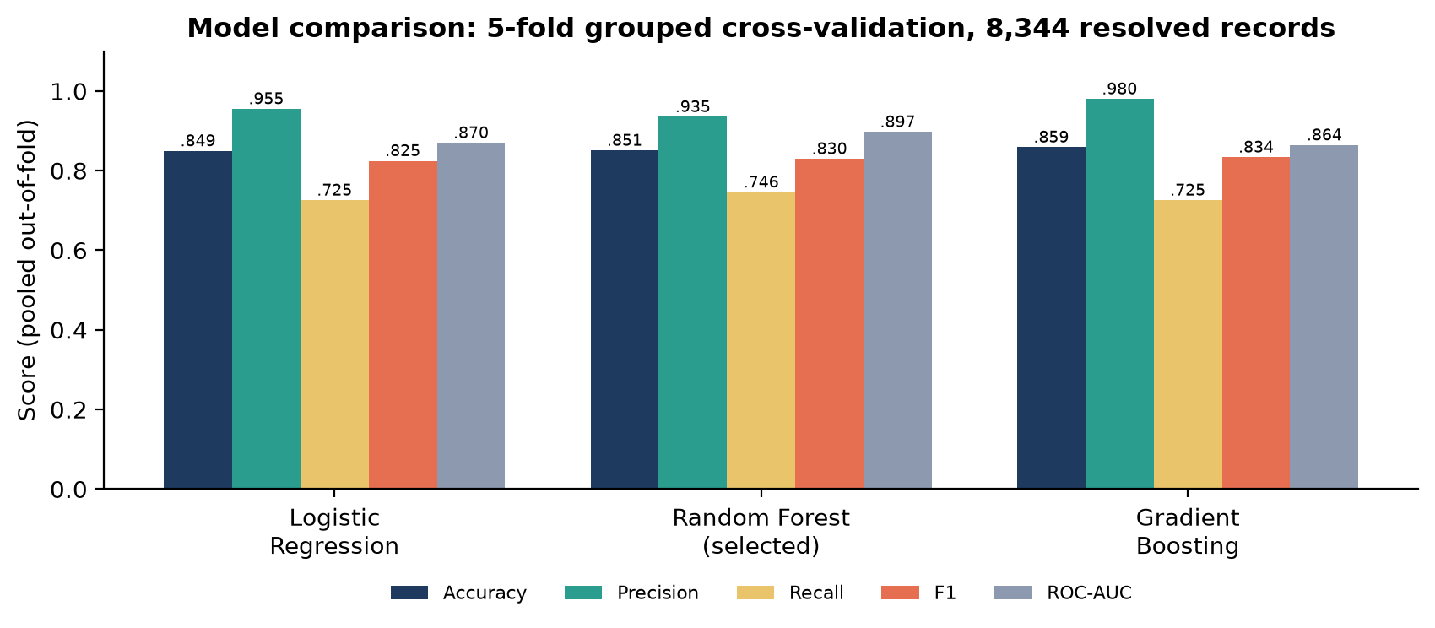
Figure 1: Out-of-fold performance of the three models (5-fold grouped cross-validation, 8,344 resolved records).
All three models perform similarly: accuracy 0.849 to 0.859, F1 0.825 to 0.834, ROC-AUC 0.864 to 0.897. High precision (0.935 to 0.980) means that a predicted participant is almost always a participant. Recall is lower (0.725 to 0.746) because the models miss internship applicants who were selected.

4.2 Confusion matrices
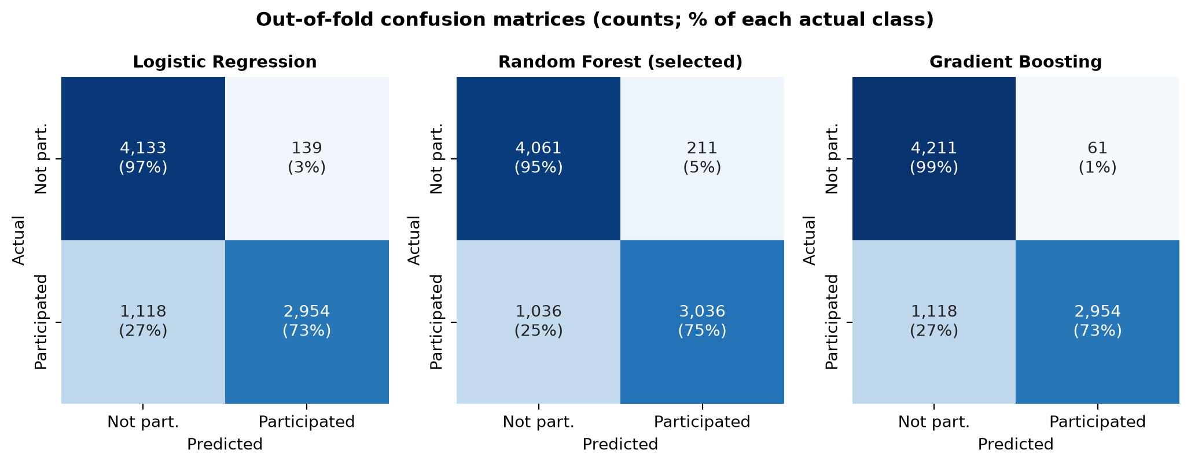
Figure 2: Out-of-fold confusion matrices for the three models (counts, with the share of each actual class).
For the selected Random Forest, 4,061 of 4,272 non-participants and 3,036 of 4,072 participants are classified correctly (211 false positives, 1,036 false negatives). All 1,036 missed participants are internship records: recall for non-internship records is 1.000, while recall for internships is only 0.111 (Table 6).

4.3 Stability across validation folds
Table 5: Random Forest performance in each validation fold
Fold | Records | Opportunities held out | Accuracy | Precision | Recall | F1-score | ROC-AUC
1 | 898 | 4 | 0.896 | 0.898 | 0.865 | 0.881 | 0.954
2 | 2,324 | 5 | 0.864 | 0.850 | 0.692 | 0.763 | 0.887
3 | 1,196 | 4 | 0.895 | 0.900 | 0.826 | 0.862 | 0.952
4 | 1,973 | 5 | 0.708 | 0.971 | 0.412 | 0.578 | 0.831
5 | 1,953 | 4 | 0.930 | 0.981 | 0.928 | 0.954 | 0.956

ROC-AUC stays between 0.83 and 0.96 in every fold, so the model separates participants from non-participants on unseen opportunities. F1 varies more (0.58 to 0.95) because each fold holds out only four or five opportunities. Fold 2 (F1 0.763) holds out the large Data Visualization and Innovation & Entrepreneurship internships. Fold 4 is the weakest (recall 0.412) because it holds out Health Care Management: 430 of its applicants participated and the model found only 2% of them. Without that one opportunity, fold 4 recall is 0.728 and F1 is 0.834.

4.4 Performance by segment
Table 6: Random Forest out-of-fold performance for internships and other categories
Segment | Records | Accuracy | Precision | Recall | F1-score | ROC-AUC
Internship | 5,406 | 0.775 | 0.417 | 0.111 | 0.175 | 0.653
Non-internship | 2,938 | 0.989 | 0.989 | 1.000 | 0.995 | n/a*
* Not meaningful: only 31 non-internship records are Not Participated.
The headline scores come mainly from separating internships from the other categories. Among internships, where the real selection decision happens, the model finds only 11% of participants (ROC-AUC 0.65). This is the main limit on how far the predictions can be used for decisions about individual internships.

4.5 Selected model and justification
Gradient Boosting has the highest F1 (0.8336), but its lead over Random Forest (0.8296) is 0.0040, inside the 0.005 tolerance. The tie is therefore decided by ROC-AUC, where Random Forest leads clearly (0.897 against 0.864 for Gradient Boosting and 0.870 for Logistic Regression). Random Forest also has the highest recall (0.746) and the lowest Brier score (0.1121), which matters because the probabilities are used for ranking and planning. Logistic Regression is 0.009 below the best F1, outside the tolerance. Random Forest is selected.
Random Forest improves only modestly on the category-only rule (same F1, ROC-AUC +0.044, Brier 0.1121 against 0.1132). Its value is in probabilities and ranking, not in classification at the 0.5 threshold.

4.6 Robustness check: chronological hold-out
A separate experiment (Colab) trained the same three algorithms on the oldest 80% of records and tested them on the newest 20%, using category and application-date features. The saved test file was re-checked for this report.
Table 7: Chronological hold-out (9 February to 10 April 2024, 1,669 records)
Predictor | Accuracy | Precision | Recall | F1-score | ROC-AUC
Gradient Boosting (Colab, best of three) | 0.993 | 0.998 | 0.984 | 0.991 | 0.992
Category-only rule on the same records | 0.993 | 0.998 | 0.984 | 0.991 | 0.991

The very high scores are correct arithmetic but reflect the test window, not model skill. The window contains 1,012 internship records, of which only 11 (1.1%) participated, against 21.6% across the whole dataset. The category-only rule matches the model on accuracy, precision, recall and F1, and the model predicted none of the 11 participating internship applicants. This agrees with the grouped cross-validation: category separation explains the score, and the model has little skill inside internships. The grouped cross-validation (Table 4) is the representative estimate.

5. Predicted Probabilities and Opportunity Ranking

5.1 How the probabilities were produced
Each record receives the probability of the Participated class from the selected Random Forest. Resolved records use out-of-fold probabilities: the score comes from a model that never saw that record’s opportunity, so it is an honest estimate and not a replay of the training data. The 214 unresolved records are scored by the final model. An opportunity’s probability is the mean over its records, and expected participants is the sum of record probabilities. Record-level probabilities for all 8,558 records and every table in this report are in the Week 3 prediction tables (Google Sheets).
Every “Predicted” figure in this report is the average of record probabilities over all records of the group, resolved and unresolved. “Actual” always means resolved records only, because unresolved records have no outcome. Averaging over resolved records alone would change any opportunity by at most 0.6 points and any category by at most 0.3 points.
A three-level rating scale turns the probabilities into a priority signal: High (0.70 or above), Medium (0.40 to 0.70) and Low (below 0.40). No opportunity falls in Medium. The dataset contains no future opportunity list or candidate learners, so “upcoming” opportunities are the existing 22 opportunities re-offered to a comparable learner population.

5.2 Opportunity ranking
Table 8: Opportunities ranked by mean predicted probability of participation
Rank | Opportunity | Category | Records | Predicted | Actual | Expected participants | Tier
1 | CPR/AED Certification | Course | 389 | 96% | 99% | 372 | High
2 | Upload Your First Year Transcript† | Engagement | 9 | 94% | 100% | 8 | High
3 | Jump Start: Developing your Emotional Intelligence | Course | 225 | 94% | 100% | 211 | High
4 | Slide Geeks: A Presentation Design Competition† | Competition | 4 | 94% | 0% | 4 | High
5 | Mental and Physical Health Session | Event | 46 | 94% | 100% | 43 | High
6 | Career Essentials: Getting Started with Your Professional Journey | Course | 1,423 | 93% | 99% | 1,330 | High
7 | Xperience Design Hackathon | Competition | 116 | 93% | 100% | 108 | High
8 | UrbanRenew Challenge | Competition | 138 | 92% | 99% | 128 | High
9 | Startup Mastery Workshop | Event | 262 | 92% | 99% | 241 | High
10 | UX Redesign Challenge | Competition | 112 | 92% | 100% | 103 | High
11 | AI Ethics Challenge† | Competition | 55 | 91% | n/a | 50 | High
12 | Freelance Mastery workshop | Event | 237 | 90% | 100% | 214 | High
13 | Join a Student Organisation | Engagement | 121 | 82% | 100% | 100 | High
14 | Innovation & Entrepreneurship | Internship | 419 | 29% | 14% | 122 | Low
15 | Data Visualization | Internship | 980 | 28% | 13% | 271 | Low
16 | Digital Marketing | Internship | 559 | 25% | 11% | 142 | Low
17 | Project Management | Internship | 836 | 25% | 13% | 211 | Low
18 | Project Management Associate | Internship | 478 | 22% | 22% | 105 | Low
19 | Data Visualization Associate | Internship | 551 | 19% | 22% | 104 | Low
20 | Health Care Management | Internship | 784 | 18% | 55% | 140 | Low
21 | Digital Strategy Virtual Internship | Internship | 331 | 17% | 22% | 56 | Low
22 | Business Consulting | Internship | 483 | 16% | 16% | 78 | Low
Predicted = mean probability over all records of the opportunity (resolved records out-of-fold, unresolved records from the final model). Actual = participation rate among resolved records only. † Fewer than 30 records (Upload Your First Year Transcript, Slide Geeks) or no resolved outcomes (AI Ethics Challenge: all 55 records are Applied). Jump Start has two IDs and is shown as one opportunity.
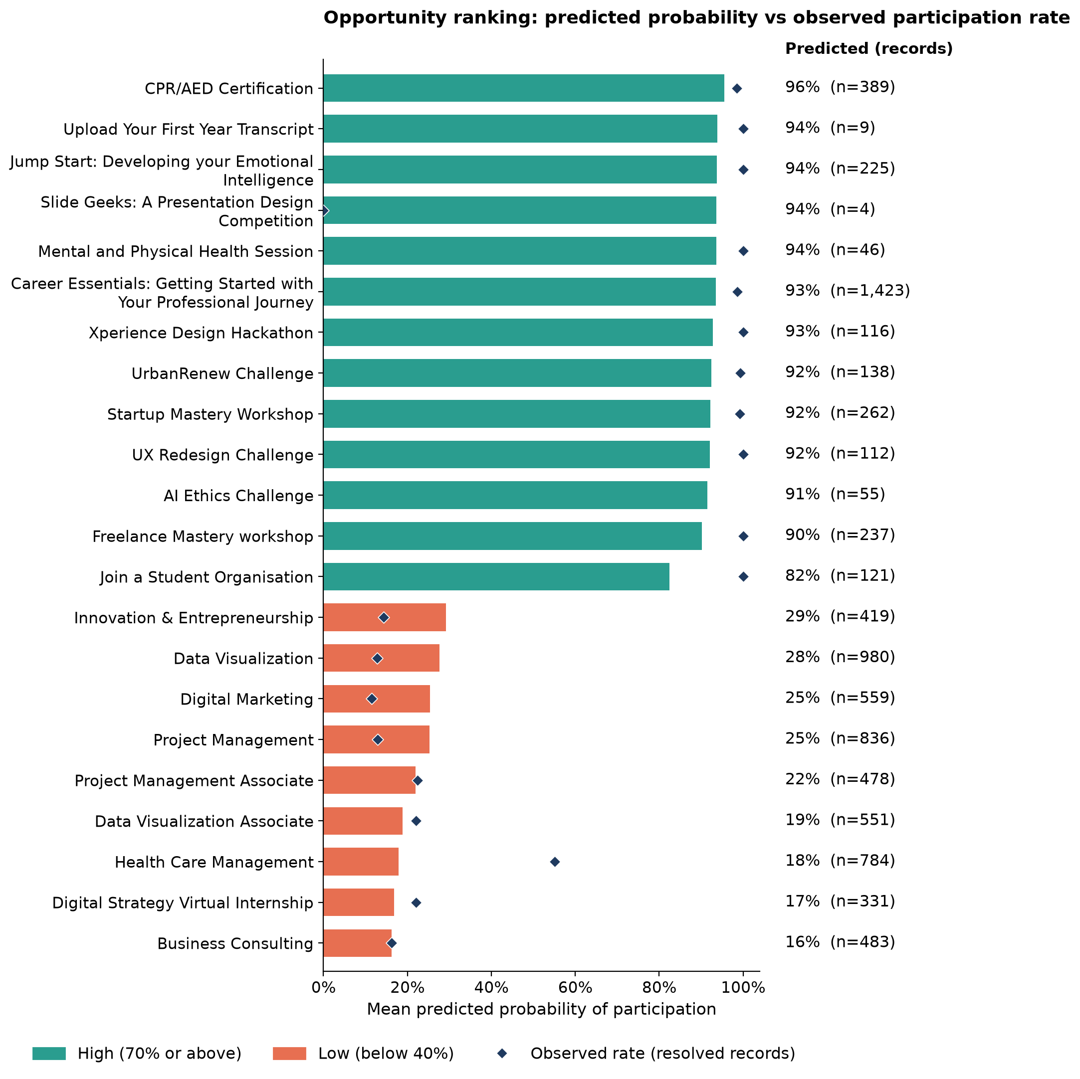
Figure 3: Predicted probability (bars) and observed participation rate (diamonds) for each opportunity.

5.3 Category performance and expected participation
Table 9: Predicted and actual participation by opportunity category
Rank | Category | Opportunities | Records | Predicted (all records) | Actual (resolved) | Expected participants | Actual participants | Tier
1 | Course | 3 | 2,037 | 93.9% | 98.8% | 1,913 | 1,898 | High
2 | Competition | 5 | 425 | 92.3% | 98.6% | 392 | 358 | High
3 | Event | 3 | 545 | 91.4% | 99.6% | 498 | 525 | High
4 | Engagement | 2 | 130 | 83.3% | 100.0% | 108 | 126 | High
5 | Internship | 9 | 5,421 | 22.7% | 21.6% | 1,229 | 1,165 | Low
Predicted = mean probability over all records of the category. Expected participants = sum of probabilities over all records, including unresolved ones. Actual = resolved records only.
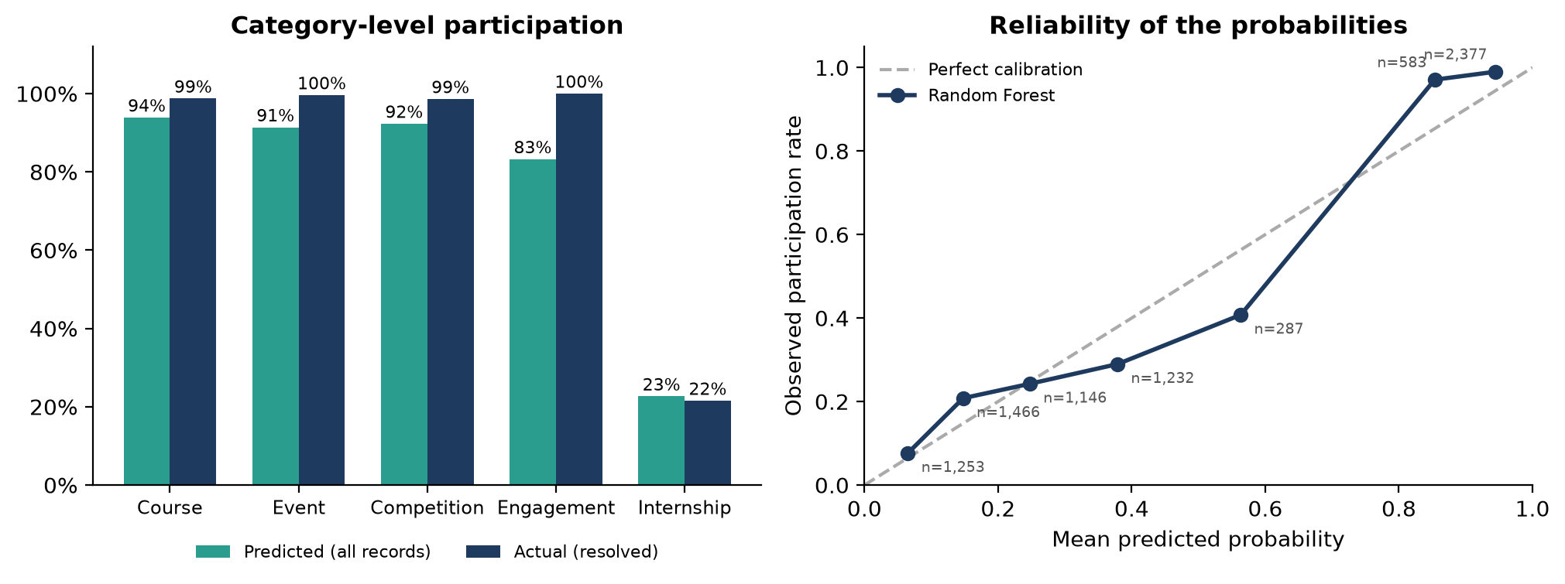
Figure 4: Left: predicted (all records) against actual (resolved records) participation by category. Right: reliability of the predicted probabilities.
At category level the model is well calibrated for internships (22.7% predicted, 21.6% actual). For courses, competitions and events it is conservative by 5 to 8 points, and for Engagement by 17 points (83% against 100%, on 126 resolved records). In total the model expects 4,140 participants across all 8,558 records, of which about 188 come from the 214 unresolved records, against 4,072 recorded among resolved records.

5.4 Opportunities most likely to attract strong participation
- Strongest (High tier, 13 opportunities, 82% to 96%): CPR/AED Certification (96%), Jump Start: Developing your Emotional Intelligence (94%), Mental and Physical Health Session (94%), Career Essentials (93%, the largest opportunity with 1,423 records) and the Xperience Design Hackathon (93%). About 99% of resolved applicants to these opportunities participated.
- Order inside the High tier is not meaningful. Twelve of the 13 sit within 90% to 96%, and the model has no opportunity-specific input. Join a Student Organisation (82%) is lower; Engagement is the smallest category (130 records) and the model rates it at 83%.
- Provisional entries. AI Ethics Challenge (91%) has no resolved outcome, so its score is a category-based estimate. Slide Geeks (4 records, all Dropped Out) and Upload Your First Year Transcript (9 records) are too small to rank.
- Internships (Low tier, 16% to 29%). Innovation & Entrepreneurship (29%) and Data Visualization (28%) score highest and Business Consulting (16%) lowest, but the spread is not informative (Section 5.5). Health Care Management is the outlier: predicted 18%, observed 55%.

5.5 How far the ranking can be trusted
Calibration (Figure 4, right): probabilities below 0.3 and above 0.7 are close to observed rates, with the model slightly conservative at the top (0.94 predicted, 0.99 observed). In the 0.3 to 0.7 band it over-predicts (for example 0.56 predicted against 0.41 observed on 287 records), mostly internship applicants.
Across the 21 opportunities with resolved outcomes, predicted and observed rates are positively rank-correlated (Spearman ρ = 0.49, p = 0.025), with a mean absolute error of 13.3 points (10.9 points weighted by records). This comes almost entirely from separating categories. Within the nine internships the correlation is negative (ρ = -0.63, p = 0.067), so the model’s order among internships carries no information. Use observed rates alongside the model for internship-level decisions.

6. Feature Importance and Heatmaps

6.1 Feature importance
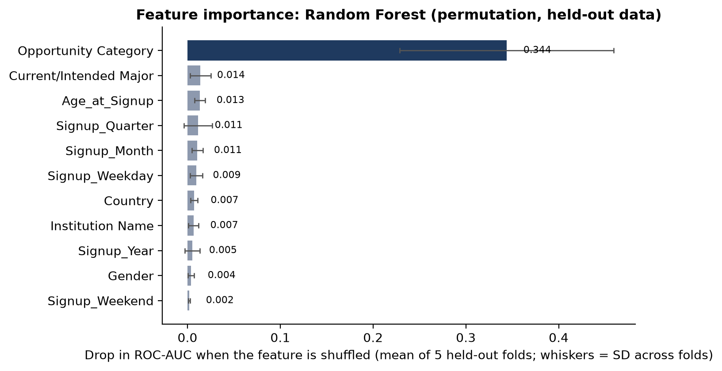
Figure 5: Permutation feature importance for the Random Forest (drop in held-out ROC-AUC; mean of five folds, whiskers show the standard deviation across folds).
Opportunity Category is by far the most influential input (ROC-AUC drop 0.344). Every other input is at or below 0.014: Current/Intended Major (0.014), Age_at_Signup (0.013), Signup_Quarter (0.011) and Signup_Month (0.011), with Signup_Weekend and Gender close to zero. Importance is associational, not causal.
The Signup_Quarter and Signup_Month effects mostly stand in for internship selectivity in the latest intake (Figure 6, left), not for a calendar effect on learner motivation.

6.2 Heatmaps of predicted participation probability
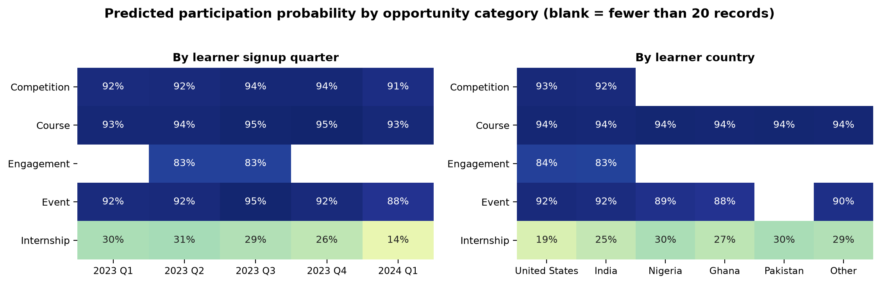
Figure 6: Mean predicted probability by opportunity category and signup quarter (left) and learner country (right).
The category split is stable over time: courses, events and competitions stay at 0.88 to 0.95 in every signup quarter. Internships sit at 0.26 to 0.31 until 2023 Q4 and fall to 0.14 for 2024 Q1 signups, the largest movement in the heatmap. It matches the observed fall in internship conversion for that intake (11.4% by signup quarters in the Week 2 cohort analysis). Country matters little for courses and events (0.88 to 0.94). For internships, United States learners score 0.19 against 0.25 to 0.30 elsewhere; because they are the largest internship group, this may reflect when they applied and was not tested. Country and institution fields should not be used to treat individual applicants differently.
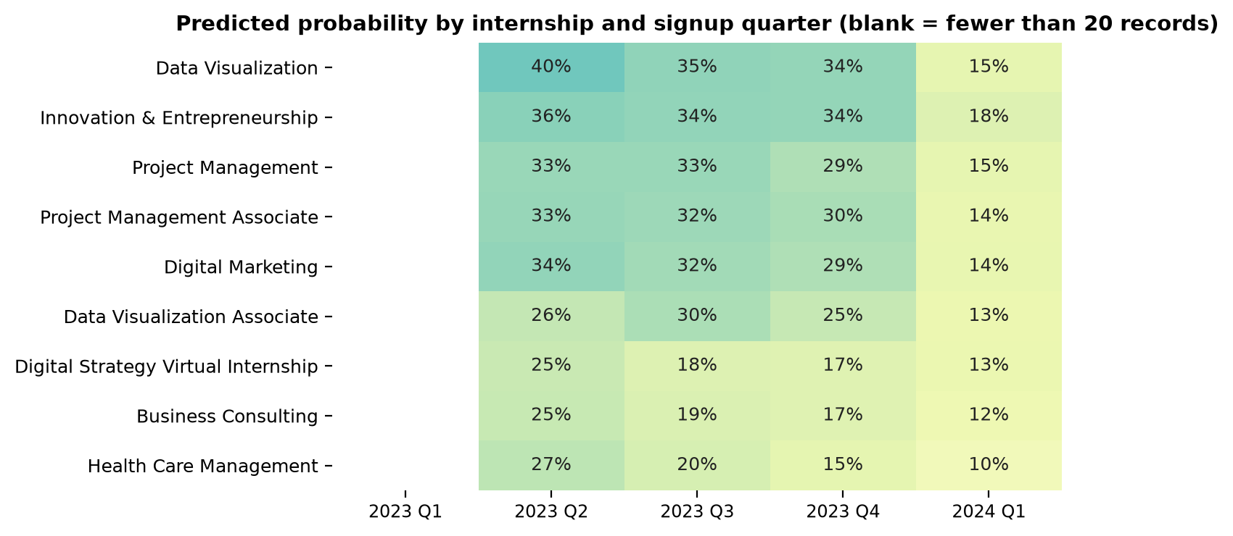
Figure 7: Predicted probability for each internship by signup quarter.
Within internships the predicted probabilities differ little between programmes (0.10 to 0.40 across all cells), while observed rates range from 11% to 55%.

7. Quarterly Analysis and Forecast

7.1 Peak quarter and volume pattern
Table 10: Applications, participation and expected participants by application quarter
Quarter | Signups | Applications | Share | Internship share | Participants (resolved) | Actual rate | Predicted rate | Expected participants
2022 Q4* | – | 43 | 0.5% | 0% | 42 | 98% | 94% | 40
2023 Q1 | 504 | 178 | 2.1% | 0% | 169 | 95% | 93% | 166
2023 Q2 | 1,442 | 602 | 7.0% | 5% | 578 | 96% | 91% | 546
2023 Q3 | 2,539 | 1,716 | 20.1% | 60% | 1,037 | 62% | 56% | 955
2023 Q4 | 1,306 | 1,218 | 14.2% | 72% | 594 | 49% | 46% | 564
2024 Q1 | 2,755 | 4,785 | 55.9% | 73% | 1,649 | 36% | 39% | 1,861
2024 Q2* | 12 | 16 | 0.2% | 50% | 3 | 27% | 54% | 9
* 2022 Q4 holds apply dates before the first signup (5 January 2023); 2024 Q2 is partial (data ends 10 April 2024). Applications are counted by Apply Date and signups by Learner Signup Date. Actual rate uses resolved records only. Predicted rate and expected participants use all records of the quarter.
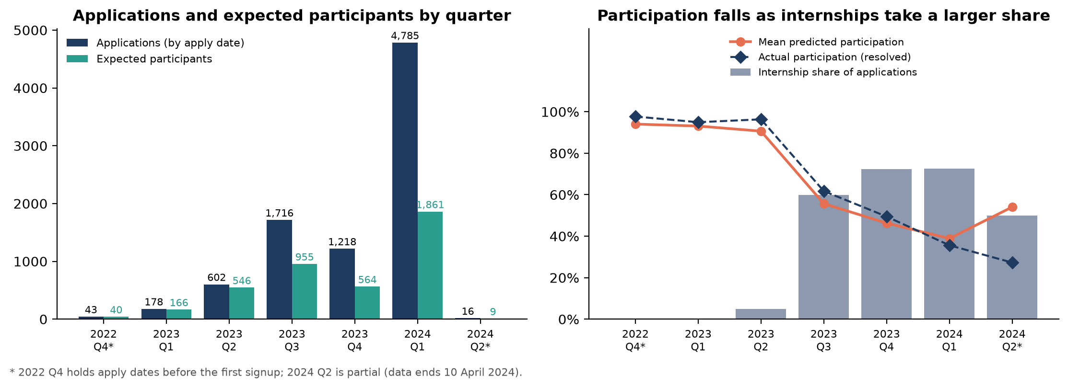
Figure 8: Applications and expected participants by quarter (left); internship share and participation rates (right).
2024 Q1 is the peak quarter on every volume measure: 4,785 applications (55.9% of all records), 2,755 signups and about 1,861 expected participants. January and February 2024 alone account for 4,401 applications (Week 2 analysis). A smaller peak sits in 2023 Q3 (1,716 applications, about 955 expected participants).
Peak volume is not peak participation rate. The highest participation rates occur in the early, course-dominated quarters (96% in 2023 Q2; 2022 Q4 has only 43 records). The rate falls to 36% in 2024 Q1 because internships rise from 5% to 73% of applications. The model reproduces this mix effect: its predicted rate stays within about 6 points of the actual rate in every full quarter.

7.2 Forecast methodology
The data holds one annual cycle of applications (2023 Q2 to 2024 Q1: 602, 1,716, 1,218 and 4,785). The base case repeats each quarter’s volume and its model-expected participation rate for the matching quarter after the data ends (2024 Q2 to 2025 Q1). The rate is the mean model probability of that reference quarter’s records, so the base-case expected participants equal the figures in Table 10. The Low and High scenarios are 25% below and above the base case; they are planning ranges, not statistical confidence intervals.
Table 11: Forecast of applications and expected participants
Forecast quarter | Based on | Apps low | Apps base | Apps high | Internship share | Part. rate | Part. low | Part. base | Part. high
2024 Q2 | 2023 Q2 | 452 | 602 | 753 | 5% | 91% | 409 | 546 | 682
2024 Q3 | 2023 Q3 | 1,287 | 1,716 | 2,145 | 60% | 56% | 716 | 955 | 1,194
2024 Q4 | 2023 Q4 | 914 | 1,218 | 1,523 | 72% | 46% | 423 | 564 | 705
2025 Q1 | 2024 Q1 | 3,589 | 4,785 | 5,981 | 73% | 39% | 1,396 | 1,861 | 2,326
Total |  | 6,241 | 8,321 | 10,401 |  |  | 2,944 | 3,925 | 4,907
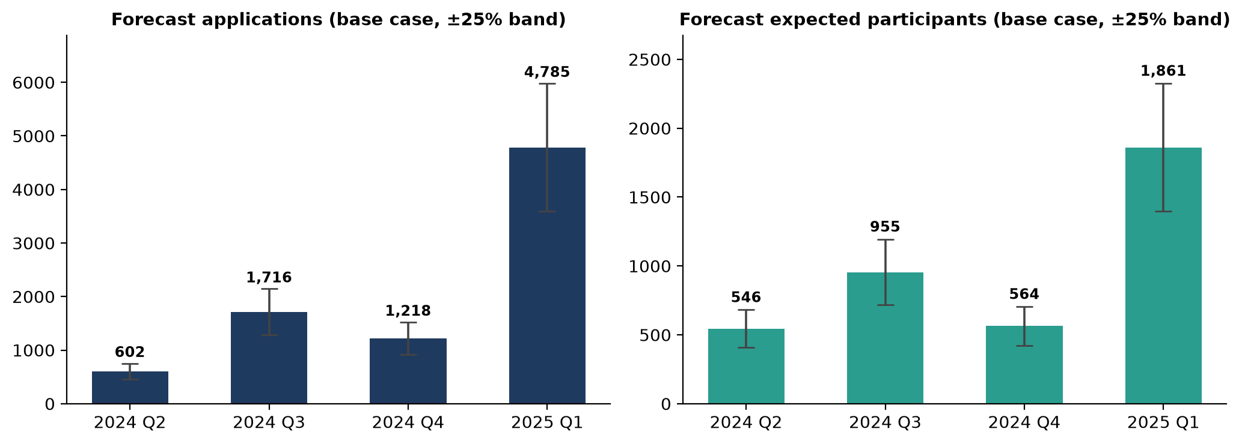
Figure 9: Base-case forecast of applications and expected participants with the ±25% planning band.
Table 12: Cross-check using recent quarters (rate taken from the same quarters as the volume)
Scenario | Source quarter(s) | Applications per quarter | Expected participation rate | Expected participants per quarter
Low | 2023 Q4 | 1,218 | 46.3% | 564
Base | 2023 Q3, 2023 Q4, 2024 Q1 | 2,573 | 43.8% | 1,127
High | 2024 Q1 | 4,785 | 38.9% | 1,861

7.3 Reading the forecast
- Peak quarter ahead: Q1. About 4,785 applications and about 1,861 expected participants in the base case (planning band 3,589 to 5,981 applications and 1,396 to 2,326 participants). Q3 is the second busiest (about 1,716 applications, 955 expected participants), followed by Q4 and Q2.
- Highest participation rate: Q2. Its reference quarter had few internships (5% of applications, 91% expected participation), but the volume is small. The Q1 peak yields the most participants.
- Both methods agree on the upper bound. Recent-quarter scenarios (Table 12) give 1,218 to 4,785 applications per quarter, and the peak of 4,785 is the highest volume in either view.
- Q2 is probably understated. Its reference quarter (2023 Q2) pre-dates the internship scale-up, so both volume (602) and participation rate (91%) are likely to look different when internships recur.
- Forecast error is large. Week 2 backtests of simple volume forecasts missed by about 50% on average (best method 50.5%), and applications grew 27 times between 2023 Q1 and 2024 Q1. The flat base case is an assumption. A statistical trend model is not used because five quarters are too few to fit one reliably.
The forecast quarters follow the end of the data (10 April 2024) and the 3 November 2024 export, so they are already past; if newer records exist, they can be used to test this forecast. Because the expected participation rate depends mainly on how many applications are internships, any volume estimate should state its assumed category mix.

8. Interpretation of Findings
- Participation is mainly a selection story. Non-internship opportunities convert about 99% of resolved applicants; internships about 22%. Of the 4,241 resolved internship records that did not participate, 3,569 (84%) were rejections.
- Internships are the volume and the bottleneck. They are 63% of all records and 72% to 73% of applications since 2023 Q4, yet produce about one participant per five applicants.
- Demand is concentrated. One window (January to February 2024) produced more than half of all applications, so review capacity and communication must peak with it.
- The model is strong where it matters least. It separates internships from other categories very well, and separates selected from not-selected internship applicants poorly.
- One programme changed behaviour. Health Care Management allocated about 80% of applicants in 2023 Q3 and Q4, then none of its 247 applications in 2024 Q1. All internships together convert at only 13.7% in 2024 Q1 on the basis of apply-dates. Whether those outcomes were final at the data cut-off should be confirmed before drawing conclusions about the latest intake.

9. Recommendations
- Plan by category. Expect about 91% to 94% predicted participation (about 99% observed) for courses, events and competitions, and about 22% for internships.
- Forecast the internship intake first. The number of internship applications moves the overall participation rate more than any other assumption.
- Prepare capacity for the Q1 window. Plan review and onboarding capacity for a January to February surge, and confirm with another year of data before calling it seasonal.
- Investigate the 2024 internship outcomes. Confirm why Health Care Management allocated no applicants from February 2024 and whether 2024 Q1 outcomes were final.
- Confirm status definitions and pending records. Agree with the data owner what each status means in each category, and resolve the 214 pending records (all 55 AI Ethics Challenge records are still Applied).
- Add opportunity-level data. Seats, applicant counts, deadlines and selection rules would let a model rank internships, which learner fields cannot do. A stable learner ID and dated outcomes would also allow repeat behaviour to be measured.
- Use the scores for planning only. Probabilities are estimates, not guarantees. Country, gender, institution and major may encode demographic differences, so scores should not be the sole basis for decisions about individual learners.

10. Limitations
- The target is a status-based grouping, not confirmed completion.
- Records are not learners: no learner ID exists, so repeat applicants cannot be controlled between folds.
- No future opportunity list or candidate learner profiles exist, so no genuine forward ranking is possible; “upcoming” opportunities are the existing ones.
- Only 21 opportunities (22 IDs, because Jump Start has two) have resolved outcomes, so each validation fold holds out four or five. Settings are baselines without tuning, and there is no external future-period validation.
- The forecast rests on one annual cycle and a flat-volume assumption; the ±25% band is a planning range.
- The models ran on the Week 2 sheet as submitted, including test accounts and date-conflict records; removing them changes no measure by more than 0.006 (Section 3.2).
- The forecast has not been tested against later data, and Table 11 is a planning range built on one annual cycle.
- The Week 1 day/month date correction is an inference that the data owner has not confirmed; it affects the weekday and quarter features.

11. AI-Assisted Analysis
Table 13: AI use, validation and results
Section | AI tool | Use | Validation and result
Refining the Compiled Report | Claude (Anthropic) | Refined the Report which compiled the team’s Week 3 files, wrote the narrative, built the tables and figures, and reconciled differences between submissions. | Re-ran the Role 2 validation: the confusion matrices of all three models match the submission exactly. Recomputed every table from out-of-fold probabilities and compared each with the member’s version (Appendix A)
Sections 4.6 and 5 | Claude | Recomputed the chronological hold-out metrics, the category-only benchmark, the in-sample versus out-of-fold probabilities, and the sensitivity re-runs | Hold-out metrics matched the member’s file exactly; in-sample category averages reproduced the Role 3 tables to within 0.3 points
Barira Khan | Claude | Used Claude to assist with report generation and to provide help with coding. | The AI assistance was reported by the team member; the coding and report content remain the team’s work.
Oladosu Rophiat | Claude | Used Claude for assistance with preparing the report. | The AI assistance was reported by the team member; no separate AI-generated technical analysis was claimed.
Khadija Kamal | ChatGPT | Used ChatGPT for coding guidance, troubleshooting errors, understanding model evaluation, and structuring the report. The implementation and model comparison were completed as her own work. | ChatGPT was used as a support tool; implementation and model comparison were carried out by the team member.
Kamoru Olayemi Raji | ChatGPT | Completed the technical work manually and used ChatGPT to help present it in a professional report format. | The technical work was completed manually; AI assistance was limited to report presentation and wording.

Appendix A. Verification of Submitted Results
Where submissions differed, each claim was recalculated from the data. The verified result is the one used in this report.
# | Item | What was submitted | Check performed | Result used
1 | Headline model performance | Colab: Gradient Boosting F1 0.991 (chronological 80/20 split). Role 2: Random Forest F1 0.830 (grouped CV) | Recomputed the Colab metrics from the saved prediction file; applied the category-only rule to the same records; re-ran the Role 2 validation | Colab scores are arithmetically correct but equal the category-only rule (F1 0.991) because the window has 1,012 internships with 11 participants. Role 2 reproduced exactly. Role 2 is the headline; Colab is Section 4.6
2 | Train/test counts | Infographic: 6,840 training and 1,710 testing records (sum 8,550) | 80/20 split of 8,344 resolved records; rows in the saved prediction file | 6,675 and 1,669 (the file has 1,669 rows). Infographic counts not used
3 | Selected model | Colab: Gradient Boosting. Role 2: Random Forest | Applied the stated rule (F1 first; ROC-AUC if within 0.005) to the verified metrics | Random Forest: F1 gap 0.0040, ROC-AUC 0.897 against 0.864
4 | Basis of probabilities | Role 3 (Barira): Role 2 model scored the records it was fitted on (in-sample). Role 3 (Rophiat): rebuilt model, out-of-fold, because the saved model was not available to her | Reproduced the in-sample scores and the exact out-of-fold scores; compared by opportunity | In-sample scores differ from out-of-fold by 4.5 points on average; the rebuilt model by 2.0 points. Exact out-of-fold probabilities are used; 214 unresolved records are scored by the saved final model
5 | Fold structure | Rebuilt folds of 2,247, 1,375, 1,986, 1,384 and 1,352 records | Reproduced the Role 2 folds (StratifiedGroupKFold, random_state 42) | Folds of 898, 2,324, 1,196, 1,973 and 1,953 records; Health Care Management is held out in fold 4
6 | Ranking statistics | Spearman ρ 0.61 (22 opportunities); internship ROC-AUC 0.68, recall 10% | Recomputed from the exact out-of-fold probabilities | ρ 0.49 (p = 0.025, 21 opportunities with outcomes); internship ρ −0.63; internship ROC-AUC 0.65, recall 11%
7 | Number of opportunities | 22 names (Barira) and 23 IDs (Rophiat) | Checked Opportunity Id against Opportunity Name | Jump Start has two IDs under one name: reported as 22 opportunities, 23 IDs noted
8 | Category calibration | Diagnostic charts described the model as remarkably well calibrated using in-sample averages | Compared out-of-fold category averages with observed rates | True for internships (22.7% against 21.6%); conservative by 5 to 17 points for other categories
9 | Forecast method | Barira: Low/Base/High pair volume from one quarter with a rate from another (acknowledged). Rophiat: repeat the 2023 Q2 to 2024 Q1 cycle with ±25% | Recomputed both with exact out-of-fold rates; compared forecast participants with the quarterly table for the same volume | Rophiat’s quarter-specific volume method is the forecast (Table 11), with each quarter’s expected rate taken from the model’s own record-level scores so that Tables 10 and 11 agree. Category-average rates would overstate the Q1 peak (2,003 against 1,861). Barira’s quarter-consistent scenario is the cross-check (Table 12)
10 | Dataset version | A consolidated report described a 22-column workbook without the Participated field | Opened the Week 2 workbook | 36 columns including Participated; counts 4,072 / 4,272 / 214 confirmed

Appendix B. Definitions
Term | Meaning in this report
Participated | Dataset-defined status label (Started, Team Allocated, Rewards Award). Not confirmed completion.
P(Participated) | Model-estimated probability that an application record belongs to the Participated class.
Out-of-fold | Scored by a model that did not see that record’s opportunity during training.
Opportunity probability | Mean P(Participated) over all records of the opportunity.
Expected participants | Sum of record probabilities (probability multiplied by records).
Tier | High: 0.70 or above. Medium: 0.40 to 0.70. Low: below 0.40.
Resolved / unresolved | Resolved records have a final outcome (Participated or Not Participated). Unresolved records are Applied or Waitlisted and are scored but not used to train or test.
Accuracy, precision, recall, F1 | Accuracy: share of correct predictions. Precision: share of predicted participants who participated. Recall: share of actual participants found. F1: balance of precision and recall.
ROC-AUC | How well the model ranks participants above non-participants: 0.5 is guessing, 1.0 is perfect.
Confusion matrix | Counts of correct and incorrect predictions for each actual class.
Grouped cross-validation | Validation in which all records of an opportunity are held out together, so the model is tested on opportunities it has not seen.
Brier score | Mean squared error of the predicted probabilities; lower is better.
Peak quarter | Quarter with the most records by Apply Date (applications) or Learner Signup Date (signups).
Forecast quarters | The four quarters after the data ends (2024 Q2 to 2025 Q1), each based on the matching quarter of 2023 Q2 to 2024 Q1.
Low / Base / High | 25% below, equal to, and 25% above the base-case volume: planning scenarios, not confidence intervals.

Appendix C. Reproducible Code
The script below re-creates the Role 2 validation exactly and produces every table in this report (run with scikit-learn 1.6.1, the version used for the saved models). The saved model files and the notebook are held by Role 2. The same script is available as a file: Week 3 analysis script (Google Drive).
"""
Team 9 - Week 3 consolidated analysis.
Re-creates the Role 2 model validation exactly (5-fold StratifiedGroupKFold by Opportunity Id, random_state=42),
then derives every downstream table (probabilities, ranking, categories, quarters, heatmaps, importance, forecast)
from the same out-of-fold probabilities so that all numbers in the report are consistent.
Run with scikit-learn 1.6.1 (the version used for the Role 2 handoff).
"""

import warnings

warnings.filterwarnings("ignore")
import pickle, joblib
import numpy as np, pandas as pd
from scipy.stats import spearmanr
from sklearn.base import clone
from sklearn.model_selection import StratifiedGroupKFold
from sklearn.inspection import permutation_importance
from sklearn.metrics import (
accuracy_score,
precision_score,
recall_score,
f1_score,
roc_auc_score,
brier_score_loss,
confusion_matrix,
)

DATA = "RIT_Week2_Cleaned_Dataset.xlsx"
HANDOFF = "all_trained_models.joblib"
SEED = 42
d = pd.read_excel(DATA, sheet_name="Week2 Cleaned Data")
d["Row"] = np.arange(len(d))
FEATS = [
"Opportunity Category",
"Gender",
"Country",
"Institution Name",
"Current/Intended Major",
"Age_at_Signup",
"Signup_Year",
"Signup_Month",
"Signup_Quarter",
"Signup_Weekday",
"Signup_Weekend",
]
res = d[d["Participated"].isin(["Participated", "Not Participated"])].reset_index(
drop=True
)
unr = d[d["Participated"] == "Applied"].reset_index(drop=True)
y = (res["Participated"] == "Participated").astype(int).values
X, G = res[FEATS], res["Opportunity Id"].values
models = joblib.load(HANDOFF) # Role 2 pipelines (fitted on all resolved records)
names = ["Logistic Regression", "Random Forest", "Gradient Boosting"]
print(
"records",
len(d),
"resolved",
len(res),
"unresolved",
len(unr),
"participated",
int(y.sum()),
)

def mets(y_, p_, thr=0.5):
pr = (p_ >= thr).astype(int)
return dict(
Accuracy=accuracy_score(y_, pr),
Precision=precision_score(y_, pr, zero_division=0),
Recall=recall_score(y_, pr, zero_division=0),
F1=f1_score(y_, pr, zero_division=0),
AUC=roc_auc_score(y_, p_) if len(set(y_)) > 1 else np.nan,
)

# ---------------- 1. Role 2 validation (exact reproduction)
cv = StratifiedGroupKFold(n_splits=5, shuffle=True, random_state=SEED)
folds = list(cv.split(X, y, G))
oof, fold_models = {}, {n: [] for n in names}
for n in names:
p = np.zeros(len(y))
for tr, te in folds:
m = clone(models[n]).fit(X.iloc[tr], y[tr])
fold_models[n].append(m)
p[te] = m.predict_proba(X.iloc[te])[:, 1]
oof[n] = p
perf = pd.DataFrame({n: mets(y, oof[n]) for n in names}).T
cms = {
n: confusion_matrix(y, (oof[n] >= 0.5).astype(int)).ravel() for n in names
} # TN FP FN TP
paper = {
"Logistic Regression": (4133, 139, 1118, 2954),
"Random Forest": (4061, 211, 1036, 3036),
"Gradient Boosting": (4211, 61, 1118, 2954),
}
repro = {n: tuple(int(v) for v in cms[n]) == paper[n] for n in names}
print(perf.round(4))
print("confusion matrices identical to Role 2 report:", repro)

fold_rows = []
for i, (tr, te) in enumerate(folds, 1):
r = mets(y[te], oof["Random Forest"][te])
r.update(
Fold=i,
Records=len(te),
Opportunities=len(set(G[te])),
Held_out=", ".join(sorted(res.iloc[te]["Opportunity Name"].unique())),
)
fold_rows.append(r)
fold_df = pd.DataFrame(fold_rows)
print(fold_df.drop(columns="Held_out").round(3))

# ---------------- 2. Segment skill and benchmarks
seg = res["Opportunity Category"].eq("Internship").values
rf = oof["Random Forest"]
seg_df = pd.DataFrame(
{"Internship": mets(y[seg], rf[seg]), "Non-internship": mets(y[~seg], rf[~seg])}
).T
rule = (~seg).astype(int) # category-only rule: non-internship => participated
bench = pd.DataFrame(
{
"Category-only rule": mets(y, rule.astype(float)),
"Majority class": mets(y, np.ones(len(y))),
}
).T
brier = {n: brier_score_loss(y, oof[n]) for n in names}
print(seg_df.round(3))
print(bench.round(3))
print("Brier", {k: round(v, 4) for k, v in brier.items()})

# ---------------- 3. Permutation importance on held-out folds (ROC-AUC drop, 5 repeats)
pi = []
for i, (tr, te) in enumerate(folds):
r = permutation_importance(
fold_models["Random Forest"][i],
X.iloc[te],
y[te],
scoring="roc_auc",
n_repeats=5,
random_state=SEED,
n_jobs=1,
)
pi.append(r.importances_mean)
pi = np.array(pi)
imp = pd.DataFrame(
{"Feature": FEATS, "AUC_drop": pi.mean(0), "SD_across_folds": pi.std(0, ddof=1)}
).sort_values("AUC_drop", ascending=False)
print(imp.round(4))

# ---------------- 4. Probabilities for every record (out-of-fold for resolved; final model for the 214 unresolved)
final = models["Random Forest"]
same = np.allclose(
final.predict_proba(X)[:, 1],
clone(models["Random Forest"]).fit(X, y).predict_proba(X)[:, 1],
)
print("saved final RF equals refit on all resolved:", same)
rec = pd.concat(
[
res.assign(prob=rf, basis="Out-of-fold"),
unr.assign(
prob=final.predict_proba(unr[FEATS])[:, 1], basis="Final model (unresolved)"
),
],
ignore_index=True,
)
rec["y"] = rec["Participated"].map({"Participated": 1, "Not Participated": 0})
insample = pd.Series(
final.predict_proba(X)[:, 1], index=res.index
) # reproduces the in-sample view
insample_cat = res.assign(p=insample).groupby("Opportunity Category")["p"].mean()
print("in-sample category means", insample_cat.round(3).to_dict())

def agg(df, key):
g = df.groupby(key)
out = pd.DataFrame(
{
"Records": g.size(),
"Resolved": g["y"].count(),
"Unresolved": g.size() - g["y"].count(),
"Actual_participants": g["y"].sum(),
"Actual_rate": g["y"].mean(),
"Pred_resolved_OOF": df[df["y"].notna()].groupby(key)["prob"].mean(),
"Pred_all": g["prob"].mean(),
"Expected_participants": g["prob"].sum(),
}
)
return out

opp = agg(rec, ["Opportunity Name", "Opportunity Category"]).reset_index()
opp["Opportunity_Ids"] = opp["Opportunity Name"].map(
rec.groupby("Opportunity Name")["Opportunity Id"].nunique()
)
tier = lambda p: "High" if p >= 0.70 else ("Medium" if p >= 0.40 else "Low")
opp["Tier"] = opp["Pred_all"].map(tier)
opp["Confidence"] = np.where(
opp["Resolved"] == 0,
"No resolved outcomes",
np.where(opp["Records"] < 30, "Low (<30 records)", "OK"),
)
opp = opp.sort_values("Pred_all", ascending=False).reset_index(drop=True)
opp.insert(0, "Rank", np.arange(1, len(opp) + 1))
cat = agg(rec, "Opportunity Category").reset_index()
cat["Opportunities"] = cat["Opportunity Category"].map(
rec.groupby("Opportunity Category")["Opportunity Name"].nunique()
)
cat["Tier"] = cat["Pred_all"].map(tier)
cat = cat.sort_values("Pred_all", ascending=False).reset_index(drop=True)
cat.insert(0, "Rank", np.arange(1, len(cat) + 1))
ok = opp[opp["Resolved"] > 0]
rho_all = spearmanr(ok["Pred_resolved_OOF"], ok["Actual_rate"])
ii = ok[ok["Opportunity Category"] == "Internship"]
rho_int = spearmanr(ii["Pred_resolved_OOF"], ii["Actual_rate"])
mae = (ok["Pred_resolved_OOF"] - ok["Actual_rate"]).abs().mean()
mae_w = np.average(
(ok["Pred_resolved_OOF"] - ok["Actual_rate"]).abs(), weights=ok["Resolved"]
)
print(
opp[["Rank", "Opportunity Name", "Records", "Actual_rate", "Pred_all", "Tier"]]
.round(3)
.to_string()
)
print(cat.round(3).to_string())
print("spearman all", rho_all, "internships", rho_int, "MAE", mae, mae_w)

# ---------------- 5. Heatmaps
def heat(col, min_n=20):
m = rec.pivot_table(
index="Opportunity Category", columns=col, values="prob", aggfunc="mean"
)
n = rec.pivot_table(
index="Opportunity Category", columns=col, values="prob", aggfunc="size"
)
return m.where(n >= min_n), n

cq, cq_n = heat("Signup_Quarter")
cc = rec.assign(
CG=np.where(
rec["Country"].isin(["United States", "India", "Nigeria", "Ghana", "Pakistan"]),
rec["Country"],
"Other",
)
)
cc_m = cc.pivot_table(
index="Opportunity Category", columns="CG", values="prob", aggfunc="mean"
)
cc_n = cc.pivot_table(
index="Opportunity Category", columns="CG", values="prob", aggfunc="size"
)
cc_m = cc_m.where(cc_n >= 20)
oq = rec[rec["Opportunity Category"] == "Internship"].pivot_table(
index="Opportunity Name", columns="Signup_Quarter", values="prob", aggfunc="mean"
)
oq_n = rec[rec["Opportunity Category"] == "Internship"].pivot_table(
index="Opportunity Name", columns="Signup_Quarter", values="prob", aggfunc="size"
)
oq = oq.where(oq_n >= 20)

# ---------------- 6. Quarterly analysis and forecast
qa = rec.groupby("Application_Quarter").agg(
Applications=("Row", "size"),
Internship=("Opportunity Category", lambda s: (s == "Internship").mean()),
Resolved=("y", "count"),
Participated=("y", "sum"),
Actual_rate=("y", "mean"),
Pred_rate=("prob", "mean"),
Expected=("prob", "sum"),
)
qa["Signups"] = rec.groupby("Signup_Quarter").size().reindex(qa.index)
qa["Share"] = qa["Applications"] / qa["Applications"].sum()
catp = rec.groupby("Opportunity Category")[
"prob"
].mean() # category mean probability (all records)
cycle = ["2023 Q2", "2023 Q3", "2023 Q4", "2024 Q1"]
labels = ["2024 Q2", "2024 Q3", "2024 Q4", "2025 Q1"]
fc_rows = []
for q, lab_ in zip(cycle, labels):
sub = rec[rec["Application_Quarter"] == q]
mix = sub["Opportunity Category"].value_counts(normalize=True)
rate = float(qa.loc[q, "Pred_rate"])
base = len(
sub
) # the reference quarter's own mean model probability (same as Table 10)
for sc, f in [("Low (-25%)", 0.75), ("Base (flat)", 1.0), ("High (+25%)", 1.25)]:
fc_rows.append(
dict(
Forecast_quarter=lab_,
Reference=q,
Scenario=sc,
Applications=base * f,
Internship_share=mix.get("Internship", 0),
Part_rate=rate,
Expected_participants=base * f * rate,
)
)
fc = pd.DataFrame(fc_rows)
alt = []
for lab_, q in [
("Low", ["2023 Q4"]),
("Base", ["2023 Q3", "2023 Q4", "2024 Q1"]),
("High", ["2024 Q1"]),
]:
s = qa.loc[q]
alt.append(
dict(
Scenario=lab_,
Source=" + ".join(q),
Applications=s["Applications"].sum() / (len(q) if lab_ == "Base" else 1),
Rate=s["Expected"].sum() / s["Applications"].sum(),
Expected=s["Expected"].sum() / (len(q) if lab_ == "Base" else 1),
)
)
alt = pd.DataFrame(alt)
print(qa.round(3))
print(fc.round(3).to_string())
print(alt.round(3))

# ---------------- 7. Calibration
bins = [0, 0.1, 0.2, 0.3, 0.5, 0.7, 0.9, 1.0001]
cal = res.assign(p=rf, y=y)
cal["bin"] = pd.cut(cal["p"], bins, right=False)
cal = (
cal.groupby("bin")
.agg(n=("y", "size"), mean_pred=("p", "mean"), actual=("y", "mean"))
.dropna()
.reset_index()
)
print(cal.round(3))

# ---------------- 8. Robustness: Kamoru chronological hold-out file
k = pd.read_csv("week3_test_predictions.csv")
kk = dict(
n=len(k),
start=k["Apply Date Parsed"].min(),
end=k["Apply Date Parsed"].max(),
n_int=int((k["Opportunity Category"] == "Internship").sum()),
int_part=int(k.loc[k["Opportunity Category"] == "Internship", "Actual"].sum()),
rate=float(k["Actual"].mean()),
)
kr = (k["Opportunity Category"] != "Internship").astype(int)
kk["gb"] = mets(k["Actual"].values, k["Probability_Participated"].values)
kk["rule"] = mets(k["Actual"].values, kr.values.astype(float))
print(kk)

# ---------------- 9. Sensitivity to rows flagged in Weeks 1-2, and fold-4 diagnostics
d_test = d["First Name"].astype(str).str.contains(r"^Test$|\dTest\d", regex=True)
d_conf = d["Apply Date"] < d["Learner Signup Date"]
labd = d["Participated"].isin(["Participated", "Not Participated"])

def rerun(mask):
s_ = d[labd & mask].reset_index(drop=True)
ys = (s_["Participated"] == "Participated").astype(int).values
p_ = np.zeros(len(ys))
for tr, te in StratifiedGroupKFold(5, shuffle=True, random_state=SEED).split(
s_[FEATS], ys, s_["Opportunity Id"]
):
m_ = clone(models["Random Forest"]).fit(s_.iloc[tr][FEATS], ys[tr])
p_[te] = m_.predict_proba(s_.iloc[te][FEATS])[:, 1]
r_ = mets(ys, p_)
r_["Records"] = len(ys)
return r_

sens = pd.DataFrame(
{
"As submitted (Week 2 sheet)": {**mets(y, rf), "Records": len(y)},
"Without test accounts": rerun(~d_test),
"Without test accounts and date-conflict rows": rerun(~d_test & ~d_conf),
}
).T
n_test_res, n_conf_res = int((d_test & labd).sum()), int((d_conf & labd).sum())
te4 = folds[3][1]
s4 = res.iloc[te4]
h4 = (s4["Opportunity Name"] == "Health Care Management").values
p4 = (rf[te4] >= 0.5).astype(int)
y4 = y[te4]
fold4 = dict(
hcm_pos=int(y4[h4].sum()),
hcm_recall=recall_score(y4[h4], p4[h4]),
recall_all=recall_score(y4, p4),
recall_ex=recall_score(y4[~h4], p4[~h4]),
f1_all=f1_score(y4, p4),
f1_ex=f1_score(y4[~h4], p4[~h4]),
)
print(sens.round(4))
print(fold4, n_test_res, n_conf_res)

pickle.dump(
dict(
perf=perf,
cms=cms,
repro=repro,
fold_df=fold_df,
seg_df=seg_df,
bench=bench,
brier=brier,
imp=imp,
opp=opp,
cat=cat,
rho_all=(rho_all.statistic, rho_all.pvalue, len(ok)),
rho_int=(rho_int.statistic, rho_int.pvalue, len(ii)),
mae=(mae, mae_w),
cq=cq,
cq_n=cq_n,
cc_m=cc_m,
cc_n=cc_n,
oq=oq,
oq_n=oq_n,
qa=qa,
fc=fc,
alt=alt,
cal=cal,
kk=kk,
same=same,
insample_cat=insample_cat,
sens=sens,
fold4=fold4,
n_flag=(n_test_res, n_conf_res),
rec=rec,
y=y,
oof=oof,
n=dict(all=len(d), res=len(res), unr=len(unr), part=int(y.sum())),
),
open("results.pkl", "wb"),
)
print("saved")

